**SIMATS SCHOOL OF ENGINEERING**

**SAVEETHA INSTITUTE OF MEDICAL AND TECHNICAL SCIENCES**

**CHENNAI-602105**

**BLOSSOM GIFTS ORDERING SYSTEM WITH SEAMLESS GIFTING EXPERIENCE**

**A CAPSTONE PROJECT REPORT**

*Submitted in the partial fulfillment for the award of the degree of*

# BACHELOROFENGINEERING

**IN**

**COMPUTER SCIENCE**

**Submitted by**

**P. Pavithra(192210611)**

**Gavini Nancy(192210285)**

**Under the Supervision of**

**Ms.L.Reetha**

**November 2024**

# DECLARATION

We, **P.Pavithra (192210611) and Gavini Nancy(192210285)** students of **Bachelor of Engineering in Computer science**, Saveetha Institute of Medical and Technical Sciences, Saveetha University, Chennai, hereby declare that the work presented in this Capstone Project Work entitled **Online blossom gifts ordering system with seamless gifting experience** is the outcome of our own bonafide work and is correct to the best of our knowledge and this work has been undertaken taking care of Engineering Ethics.

P.Pavithra,192210611

Gavini Nancy,192210284

Date:22-11-2024

Place: Chennai

# CERTIFICATE

This is to certify that the project entitled **“Online Blossom Gifts ordering system with seamless gifting experience”** submitted by **P.Pavithra and Gavini Nancy** has been carried out under my supervision. The project has been submitted as per the requirements in the current semester of BE. Computer science and technology.

Teacher-in-charge Ms.L.Reetha

**Table of Contents**

|  |  |
| --- | --- |
| **S.NO** | **TOPICS** |
| 1 | **Abstract** |
| 2 | **Introduction** |
| 3 | **Project Description** |
| 4 | **Problem Description** |
| 5 | **Tool Description**  4.1Front end  4.2Back end |
| 6 | **Operations**  5.1 Product management  5.2 Orders management  5.3 Customer account management  5.4 Payment processing  5.5 Customer service management  5.6 Promotions and Discounts |
| 7 | **Approach / Module Description / Functionalities**  6.1 User Authentication Module  6.2 Quiz Management  6.3 Quiz Taking  6.4 Performance Analysis  6.5 User Profile  6.6 Admin |
| 8 | **Implementation** |
| 9 | **Output** |
| 10 | **Conclusion**  9.1Future Enhancement |
|  | **References** |

## 1.Abstract

Blossom Gifts is an innovative e-commerce platform designed to simplify the process of ordering flowers and gifts for any occasion. It features a vast selection of floral arrangements, gift baskets, and customizable gifts, organized by occasion, recipient, and price range to facilitate easy navigation. Key functionalities include a robust user authentication system, a versatile order management setup, and the ability to schedule deliveries with specific date and time options.

The platform enhances user experience with high-quality product images and detailed descriptions, aiding in informed purchasing decisions. Customers enjoy real-time order tracking and receive delivery notifications via email or SMS, all while benefiting from a secure payment system that accommodates various transaction methods. Additionally, Blossom Gifts includes features for customer retention, such as personalized promotions and loyalty rewards. Designed for scalability, Blossom Gifts aims to provide a smooth and efficient user experience while ensuring high operational standards and customer satisfaction through prompt, reliable deliveries.

In addition to its diverse product offerings, Blossom Gifts prioritizes a seamless shopping journey. The customizable order management system allows users to personalize their gifts with messages and choose from various delivery options, including same-day delivery for last-minute surprises. Customers can easily create accounts to save their preferences, view order history, and manage upcoming deliveries.

Blossom Gifts also understands the importance of staying connected. Customers receive realtime updates about their orders, from confirmation to dispatch, ensuring peace of mind throughout the shopping process. The secure payment gateway supports a wide array of options, including credit cards, digital wallets, and cash on delivery, making transactions smooth and safe.

To cultivate customer loyalty, Blossom Gifts provides exclusive promotions and rewards for returning shoppers. This approach not only boosts customer engagement but also inspires them to share their positive experiences with friends and family. With a strong commitment to quality service and prompt deliveries, Blossom Gifts establishes itself as the premier destination for thoughtful gifts and beautiful floral arrangements, dedicated to making every occasion memorable.

## 2.Introduction

Welcome to Blossom Gifts, your premier online destination for effortlessly ordering flowers and gifts for any occasion. We are dedicated to providing a seamless, user-friendly experience that meets all your gifting needs, whether you’re celebrating a birthday, an anniversary, or just want to bring a smile to someone’s face. Our diverse collection features stunning floral arrangements, charming gift baskets, and customizable gifts, all thoughtfully organized by occasion, recipient, and price range for easy browsing.

Blossom Gifts is designed with essential features to enhance your shopping experience. Enjoy a simple user registration and login process, along with a versatile order management system that allows you to select your preferred delivery dates and times. Each product comes with detailed descriptions and high-quality images, helping you make informed choices that resonate with your recipients.

Stay connected and informed with real-time order tracking, the ability to schedule future deliveries, and timely notifications via email or SMS. We understand that security is paramount, which is why we offer multiple safe payment options to ensure your transactions are secure.

In addition to our wide array of products, Blossom Gifts rewards customer loyalty with exclusive promotions and discounts. Our goal is to make the process of sending thoughtful gifts and flowers as convenient as possible, ensuring prompt deliveries and total customer satisfaction.

At Blossom Gifts, we believe that every occasion deserves to be celebrated with love and thoughtfulness. That's why we're committed to curating a unique shopping experience that not only meets your needs but also exceeds your expectations. Whether you’re sending a surprise bouquet or a personalized gift, we’re here to help you create unforgettable moments for you and your loved ones.

At Blossom Gifts, we understand that every gift tells a story and holds the power to convey emotions. That’s why we’ve meticulously curated our selection to ensure there’s something for everyone, no matter the occasion. From elegant roses and vibrant seasonal blooms to unique gift baskets filled with treats and personalized items that add a special touch, our offerings are designed to delight and inspire.

We believe that celebrating life’s moments should be joyful and stress-free. That’s why we’re committed to providing timely delivery, allowing you to send your gifts directly to your loved ones’ doorsteps, regardless of distance. Plus, with our easy-to-use scheduling feature, you can plan ahead and surprise someone special even when you can’t be there in person.

Join our growing community of satisfied customers who trust Blossom Gifts to bring joy and connection through thoughtful gifting. We’re excited to be part of your celebrations and look forward to helping you create beautiful memories that will last a lifetime.

## Project Description

"My **Online Blossom Gifts ordering system with seamless gifting experience** " is a comprehensive web application developed to streamline hotel management. The application includes:

**Proposed Method**

* **Frontend Development**: Utilizing Visual Studio for designing responsive and intuitive user interfaces.
* **Backend Development**: Using XAMPP stack (Apache, MySQL, PHP) to handle server-side scripting, database management via phpMyAdmin, and ensuring secure data storage and retrieval.

**About my project:**

The “**Online Blossom Gifts Ordering System**” is an innovative e-commerce platform designed to provide users with a seamless and enjoyable experience for ordering flowers and gifts for any occasion. This system streamlines the gifting process, making it easier for customers to find, customize, and send thoughtful gifts that bring joy to their loved ones.

1. **User-Friendly Interface:**
   * A clean, intuitive design that allows users to navigate effortlessly through categories of flowers and gifts based on occasion, recipient, and price range.
2. **Extensive Product Catalo:**
   * A diverse selection of floral arrangements, gift baskets, and personalized gifts, each accompanied by high-quality images and detailed descriptions to help customers make informed decisions.
3. **Customizable Orders:**
   * Options to personalize gifts with custom messages and select delivery dates and times, ensuring each order is special and tailored to the recipient’s preferences.
4. **Secure User Registration and Login:**
   * A straightforward registration process that allows users to create accounts, save their preferences, and track their order history easily.
5. **Real-Time Order Tracking:**
   * Customers can monitor their orders from placement to delivery, receiving updates via email or SMS to stay informed throughout the process.
6. **Multiple Secure Payment Options:**
   * A secure payment gateway that supports various transaction methods, including credit cards, digital wallets, and cash on delivery, ensuring peace of mind for customers.
7. **Promotions and Discounts:**
   * Exclusive offers and loyalty rewards to encourage repeat business and enhance customer engagement.
8. **Sustainability Commitment:**
   * A focus on ethical sourcing and sustainability, partnering with local growers and artisans to ensure high-quality products while supporting local communities.

## 3.Problem Description

In today’s fast-moving world, finding time to shop for the perfect gift or bouquet for a special occasion can be a challenge. Whether it’s a birthday, anniversary, or a gesture of appreciation, many struggle to make the process easy and personal. Traditional shopping methods require significant time and effort, while online platforms often fall short in providing the seamless experience customer’s desire. People who want to send thoughtful, personalized gifts over long distances often face limitations and frustrations in navigating existing online options.

Customers commonly encounter several roadblocks when ordering flowers or gifts online:

1. **Limited Product Variety & Personalization:** Many platforms provide only a narrow selection of products, offering little flexibility for customization based on the specific occasion or recipient.
2. **Clunky User Experience:** Disorganized websites with confusing layouts, unclear product details, and difficult navigation can make the shopping process frustrating, discouraging users from returning.
3. **No Real-Time Tracking:** Shoppers often feel left in the dark, unsure if their orders will arrive on time or if any issues arise during delivery.
4. **Unreliable Delivery Services:** Late or missed deliveries can diminish the impact of a well-intended gift, leading to disappointment.
5. **Concerns Over Payment Security:** In today’s digital age, customers are increasingly cautious about the security of their financial data, especially when dealing with unfamiliar platforms that may not provide robust payment protections.
6. **Lack of Engagement Features:** Many gifting platforms overlook customer retention strategies, such as loyalty rewards or personalized promotions, missing the opportunity to build lasting relationships with their users.

Blossom Gifts steps in to resolve these common challenges with a platform designed to simplify the gifting process. With an extensive range of customizable floral arrangements and gift options, users can effortlessly personalize their orders for any occasion. The platform also boasts user-friendly navigation, making it easy for customers to find exactly what they need with clear product descriptions and high-quality images.

To ease concerns, Blossom Gifts offers real-time order tracking, allowing customers to monitor their deliveries at every step. The platform’s secure payment options ensure that all transactions are protected, giving users peace of mind. Blossom Gifts also includes a flexible delivery system, ensuring timely deliveries that match the customer’s schedule.

Furthermore, by offering exclusive loyalty rewards and tailored promotions, Blossom Gifts fosters a lasting connection with its customers, encouraging them to return for future gifting needs.

By addressing these common pain points, Blossom Gifts aims to be the trusted platform where individuals can rely on a personalized, convenient, and reliable gifting experience, ensuring that every occasion is made special with ease and efficiency.

## 4.Tools Description

**Front-End Technologies:** Blossom Gifts uses a combination of front-end technologies to create a visually appealing and user-friendly interface that enhances the shopping experience for customers.

1. **HTML (Hypertext Markup Language):**
   * HTML is used as the core structure of the Blossom Gifts website, defining the content and layout of each page. It organizes elements like product listings, categories, and customer interaction forms, ensuring clear presentation and easy navigation.
2. **CSS (Cascading Style Sheets):**
   * CSS is utilized to style the website, ensuring a modern, attractive, and responsive design. It controls the appearance of text, images, buttons, and other elements, providing a cohesive look across different devices, from desktops to smartphones.
3. **JavaScript:**
   * JavaScript is responsible for adding interactivity and dynamic functionality to the platform. Features such as real-time order tracking, product filtering, form validation, and customizable order options (e.g., delivery date and time selection) are made possible through JavaScript. It enhances user experience by making the platform more responsive and interactive.

**Back-End Technologies:**

1. **XAMPP Software:**

o XAMPP is used as the development environment for the back-end of Blossom Gifts. It includes essential components such as:

* **Apache:** A web server that handles requests and serves the platform’s web pages to users.
* **MySQL Database:** Stores customer data, product information, orders, and payment details. MySQL allows the platform to manage large amounts of data efficiently, ensuring smooth and reliable operations.
* **PHP:** A server-side scripting language used to handle form submissions, interact with the MySQL database, and manage the logic behind customer registrations, order processing, and payment handling.

XAMPP serves as a local development server that facilitates the integration of the front-end with the back-end, allowing developers to test and refine the platform before deploying it.

**Development Environment:**

5. **VS Code (Visual Studio Code):**

o **Visual Studio Code** is used as the primary code editor for developing Blossom Gifts. It supports the editing of HTML, CSS, JavaScript, and PHP files, providing tools for efficient coding, debugging, and version control. With features like syntax highlighting, integrated terminal, and extensions for various programming languages, VS Code enhances the development workflow, making it easier to build and maintain the platform.

## 5.Operations

The online shopping application provides various operations for both administrators and users to manage purchases effectively and ensure a smooth user experience. Below are the detailed operations based on the provided code and functionalities of the application:

**5.1 Product Management**

Product Listings: Administrators can add, modify, or remove products from the online store, ensuring up-to-date product information.

Inventory Management: The system tracks inventory levels in real-time, updating stock availability as orders are placed and fulfilled.

**5.2 Order Management**

Order Placement: Users can browse products, add items to their cart, and place orders through the system.

Order Tracking: The system provides real-time updates on the status of orders, from processing to shipment and delivery.

**5.3 Customer Account Management**

Registration and Login: Users can create accounts and log in to access personalized features such as order history and saved preferences.

Profile Management: Users can update their personal information, including shipping addresses and payment details.

**5.4 Payment Processing**

Transactions: Payments are processed through the system using various methods (credit cards, digital wallets).

Billing: The system generates invoices and tracks financial transactions, providing users with receipts and administrators with financial reports.

**5.5 Customer Service Management**

Support Requests: Users can contact customer support for assistance, and the system tracks and assigns these requests to the appropriate staff.

Feedback and Reviews: The system allows users to leave reviews and ratings for products, helping improve service and product quality.

**5.6 Promotions and Discounts**

Campaign Management: Administrators can create and manage promotional campaigns, including discounts, coupon codes, and special offers.

Loyalty Programs: The system supports loyalty programs, rewarding repeat customers with points, discounts, or other incentives.

## 6.Approach / Module Description / Functionalities

The Online Blossom gifts ordering System provides a comprehensive solution for managing e-commerce operations efficiently. It integrates various functions into a single platform, making it easier to handle product listings, order processing, customer management, and financial transactions.

**Module Description and Functionalities 1. Customer Management**

**Description:** Manages customer information and interactions.

**Functionalities:**

* **Customer Profiles:** Create and update customer details.
* **Order History:** Track customer purchase history and preferences.
* **Account Management:** Handle customer registrations, logins, and account settings.

1. **Product Management**

**Description:** Oversees product listings and inventory.

**Functionalities:**

* + **Product Listings:** Add, update, and remove product details.
  + **Inventory Management:** Track product stock levels.
  + **Category Management:** Organize products into categories for easy navigation.

1. **Order Management**

**Description:** Handles order processing and fulfilment.

**Functionalities:**

* + **Order Placement:** Process customer orders.
  + **Order Tracking:** Update order status and track shipments.
  + **Returns and Refunds:** Manage product returns and issue refunds.

1. **Payment Processing**

**Description:** Manages financial transactions securely.

**Functionalities:**

* + **Payment Gateway Integration:** Process payments through various methods (credit card, PayPal, etc.).
  + **Billing:** Generate invoices for customers.
  + **Transaction History:** Track and report on all financial transactions.

1. **Shipping Management**

**Description:** Oversees logistics and delivery.

**Functionalities:**

* + **Shipping Options:** Provide various shipping methods.
  + **Shipment Tracking:** Track packages from warehouse to delivery.
  + **Rate Calculation:** Calculate shipping costs based on location and package weight.

1. **Marketing and Promotions**

**Description:** Manages marketing campaigns and promotional offers.

**Functionalities:**

* + **Discounts and Coupons:** Create and manage promotional codes.
  + **Email Marketing:** Send newsletters and promotional emails to customers. • **Analytics:** Track the effectiveness of marketing campaigns.

1. **Reporting and Analytics**

**Description:** Provides insights through data analysis.

**Functionalities:**

* + **Sales Reports:** Generate reports on sales, revenue, and product performance.
  + **Customer Analytics:** Analyse customer behaviour and preferences. • **Inventory Reports:** Track stock levels and product turnover rates.

1. **Customer Support**

**Description:** Manages customer service interactions. **Functionalities:**

* + **Support Tickets:** Handle customer inquiries and complaints.
  + **Live Chat:** Provide real-time assistance to customers.
  + **FAQs:** Maintain a database of frequently asked questions for self-service.

1. **Security Management**

**Description:** Ensures the security of customer data and transactions.

**Functionalities:**

* + **Data Encryption:** Protect sensitive information through encryption.
  + **User Authentication:** Implement secure login processes.
  + **Fraud Detection:** Monitor and prevent fraudulent activities.

## 7.Implementation

**Home code:**

<!DOCTYPE html>

<html lang="end">

<head>

<meta charset="UTF-8">

<meta name="viewport" content="width=device-width, initial-scale=1.0">

<title>Blossom Gifts - Home</title>

<link reel="stylesheet" href="https://cdnjs.cloudflare.com/ajax/libs/font-awesome/6.0.0beta3/css/all.min.css">

<style>

* {

margin: 0; padding: 0;

box-sizing: border-box;

}

body, html {

height: 100%;

font-family: Arial, sans-serif;

}

body {

background-image: url('background.jpg'); background-size: cover; background-position: center; display: flex; flex-direction: column; align-items: center;

justify-content: center;

padding-top: 60px; /* Space for header */

}

.header { background-color: #af4c7c; color: white; padding: 15px; text-align: center; width: 100%;

position: fixed; top: 0; left: 0;

z-index: 1000; /* Ensure it stays above other content */

}

.back-button { position: absolute; top: 10px; right: 20px; background-color: #050f06;

color: white; border: none; padding: 10px 20px; cursor: pointer; font-size: 16px; border-radius: 5px;

}

.back-button:hover { background-color: #080a08;

}

.container { display: flex; flex-direction: column; justify-content: center; align-items: center;

background-color: rgba(255, 255, 255, 0.8); border-radius: 8px; padding: 40px; /* Increased padding for larger fieldset */ box-shadow: 0 0 15px rgba(0, 0, 0, 0.2); /* Larger shadow */

width: 500px; /* Enlarge the fieldset */

}

fieldset {

text-align: center; margin-bottom: 40px;

}

legend {

font-size: 2.5em; /* Enlarge "Welcome to BlossomGifts!" text */ font-weight: bold; margin-bottom: 20px;

}

.heart-button { display: inline-flex; align-items: center;

justify-content: center;

background-color: #87CEEB; /* Sky blue for round button */

color: #000; /* Black text inside */ border: none; padding: 20px; border-radius: 50%; cursor: pointer; font-size: 1.25em; text-decoration: none;

position: relative;

width: 120px; /* Width for heart shape */

height: 120px; /* Height for heart shape */

text-align: center;

}

.heart-button:before,

.heart-button:after { content: ''; position: absolute; top: 0; width: 60px; height: 100px; border-radius: 50px 50px 0 0;

background: #FF69B4; /* Pink heart shape */

}

.heart-button:before { left: 60px; transform: rotate(-45deg); transform-origin: 0 100%;

}

.heart-button:after { left: 0; transform: rotate(45deg); transform-origin: 100% 100%;

}

.heart-button:hover { background-color: #72B3DB; /* Slightly darker sky blue on hover */

}

.heart-text { position: relative; z-index: 1; text-align: center;

line-height: 1.2;

}

.button-group { display: flex;

justify-content: space-between;

flex-wrap: wrap;

gap: 30px; /* Gap for space between buttons */

margin-bottom: 20px;

}

</style>

</head>

<body>

<div class="header">

<h1>Radha's Gifted blooms</h1>

<button class="back-button" onclick="location.href='welcome.html'">Back</button>

</div>

<div class="container">

<fieldset>

<legend>Welcome to BlossomGifts!</legend>

<div class="button-group">

<button class="heart-button" onclick="location.href='items.html'">

<span class="heart-text">View Items</span>

</button>

<button class="heart-button" onclick="location.href='cart.html'">

<span class="heart-text">View Cart</span>

</button>

</div>

<div class="button-group">

<button class="heart-button" onclick="location.href='wishlist.html'">

<span class="heart-text">View Wishlist</span>

</button>

<button class="heart-button" onclick="location.href='orders.html'">

<span class="heart-text">View Orders</span>

</button>

</div>

</fieldset>

</div>

</body> </html>

**Cart code:**

<!DOCTYPE html>

<html lang="en">

<head>

<meta charset="UTF-8">

<meta name="viewport" content="width=device-width, initial-scale=1.0">

<title>Shopping Cart - BlossomGifts</title>

<style>

* {

margin: 0; padding: 0;

box-sizing: border-box;

}

body, html {

font-family: Arial, sans-serif;

height: 100%;

background-image: url('cart background.jpg'); background-size: cover;

background-position: center; background-repeat: no-repeat;

margin: 0; padding: 0;

}

.header { background-color: #8B4513; /* Brown */

color: white; padding: 15px; text-align: center; width: 100%;

position: relative; /* Position relative to place buttons inside */

}

.header h1 { margin: 0;

}

/* Navigation buttons */

.nav-btn { position: absolute; top: 15px; background-color: white; color: #8B4513; /* Brown */ padding: 10px 20px; text-decoration: none; border-radius: 5px; font-size: 1em; border: 2px solid #8B4513; /* Border to match the theme */

}

.nav-btn:hover { opacity: 0.9; background-color: #f2f2f2; /* Lighter gray on hover */

}

.home-btn { left: 20px;

}

.items-btn { right: 20px;

}

.container { max-width: 1200px; margin: 20px auto; padding: 20px; background-color: white; border-radius: 8px;

box-shadow: 0 0 10px rgba(0, 0, 0, 0.1);

}

.cart-item { display: flex; align-items: center; border-bottom: 1px solid #ddd; padding: 15px 0;

}

.cart-item img { width: 100px; height: 100px; object-fit: cover; border-radius: 4px; margin-right: 15px;

}

.cart-item .details { flex-grow: 1;

}

.cart-item .name { font-size: 1.2em; color: #8B4513; /* Brown */

}

.cart-item .price { font-size: 1.1em; color: #8B4513; /* Brown */

}

.cart-item .quantity { display: flex; align-items: center; justify-content: center;

flex-direction: column; /* Center elements vertically */

margin: 0 15px;

}

.quantity-input { width: 60px; height: 30px; font-size: 1em;

text-align: center; margin-bottom: 10px; /* Adjust space between input and price */ }

.cart-item .remove-btn { background-color: #ff4d4d; /* Red */

color: white; padding: 10px 15px; border: none; border-radius: 5px; cursor: pointer; font-size: 0.9em;

}

.cart-item .remove-btn:hover { opacity: 0.9;

}

.total, .checkout-all { margin-top: 20px; text-align: right; font-size: 1.2em; font-weight: bold;

}

.btn { display: inline-block; background-color: #8B4513; /* Brown */

color: white; padding: 10px 20px; border-radius: 5px; text-decoration: none; font-size: 1em;

}

.btn:hover { opacity: 0.9;

}

</style>

</head>

<body>

<div class="header">

<a href="home.html" class="nav-btn home-btn">Home</a>

<h1>Shopping Cart</h1>

<a href="items.html" class="nav-btn items-btn">Items</a>

</div>

<div class="container">

<div id="cartContainer">

<!-- Cart items will be inserted here -->

</div>

<div class="total">

Total: ₹<span id="totalAmount">0.00</span>

</div>

<div class="checkout-all">

<a href="#" class="btn" onclick="checkoutAll()">Checkout All Items</a> </div>

</div>

<script> let cartItems = [];

// Load cart from localStorage function loadCart() { const savedCart = localStorage.getItem('cart'); cartItems = savedCart ? JSON.parse(savedCart) : []; updateCart();

}

function updateCart() { const cartContainer = document.getElementById('cartContainer'); let totalAmount = 0; cartContainer.innerHTML = ''; // Clear existing items

cartItems.forEach((item, index) => {

const itemTotal = item.price * item.quantity; totalAmount += itemTotal;

const itemDiv = document.createElement('div');

itemDiv.classList.add('cart-item'); itemDiv.innerHTML = `

<img src="${item.image}" alt="${item.name}">

<div class="details">

<p class="name">${item.name}</p>

<p class="price">₹${item.price.toFixed(2)}</p>

</div>

<div class="quantity">

<input type="number" class="quantity-input" value="${item.quantity}"

min="1" onchange="updateQuantity(${index}, this.value)">

<p>₹${itemTotal.toFixed(2)}</p>

</div>

<button class="remove-btn"

onclick="removeItem(${index})">Remove</button>

`;

cartContainer.appendChild(itemDiv);

});

document.getElementById('totalAmount').innerText = totalAmount.toFixed(2); localStorage.setItem('cart', JSON.stringify(cartItems)); }

function updateQuantity(index, newQuantity) { cartItems[index].quantity = parseInt(newQuantity, 10); updateCart();

}

function removeItem(index) { cartItems.splice(index, 1); updateCart();

}

function checkoutAll() { localStorage.setItem('cart', JSON.stringify(cartItems)); localStorage.setItem('totalAmount',

document.getElementById('totalAmount').innerText); window.location.href = 'payment.html'; // Redirect to payment page

}

// Initialize cart on page load

loadCart();

</script>

</body>

</html>

## 8.Output

**Welcome page:**

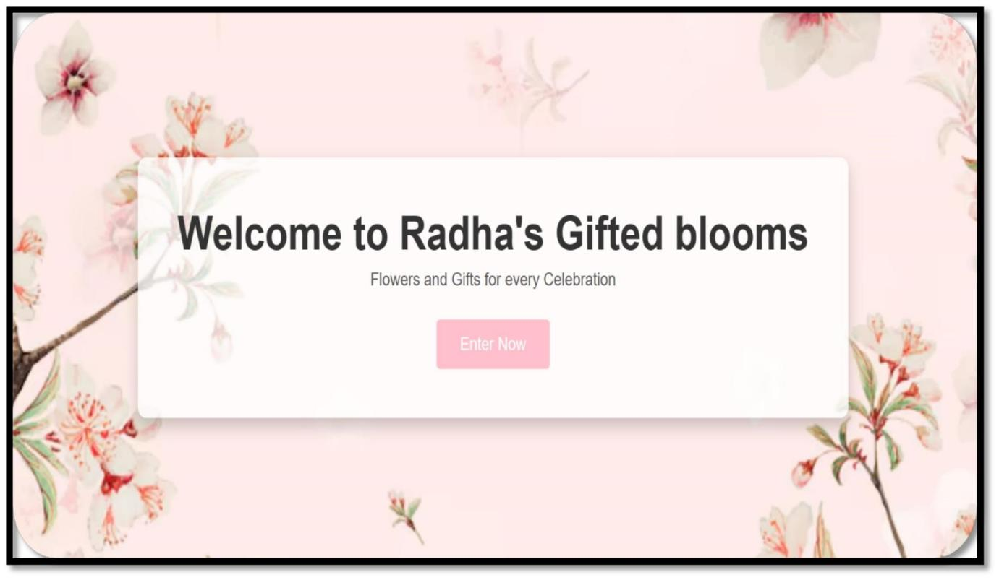

**Homepage:**

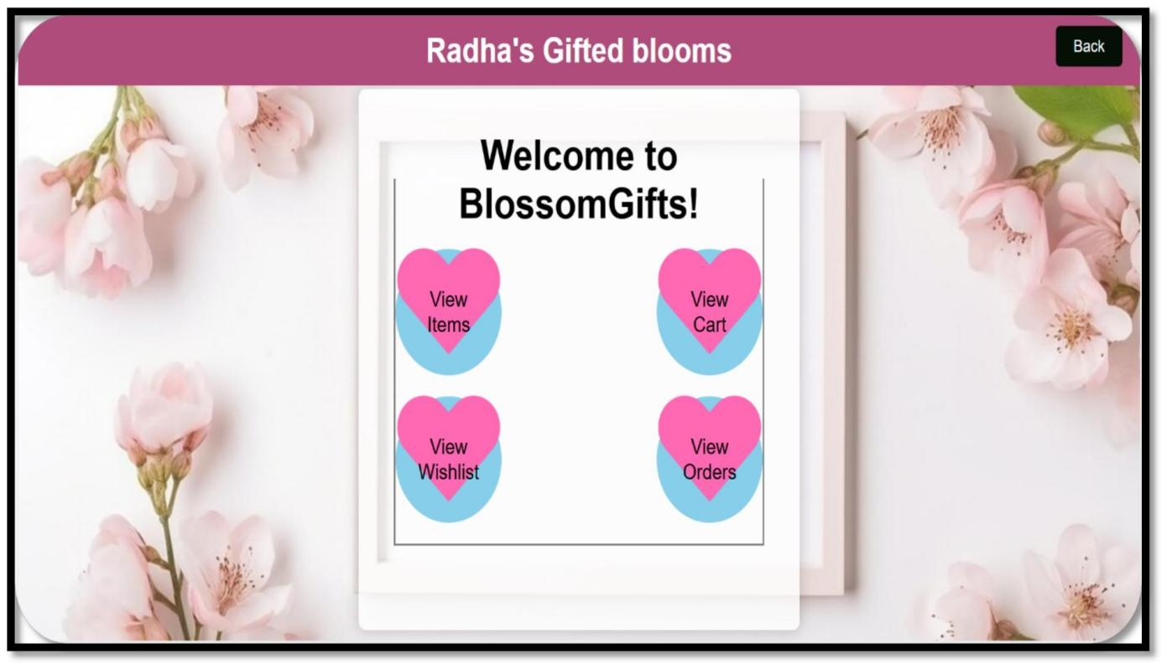

**List of items:**

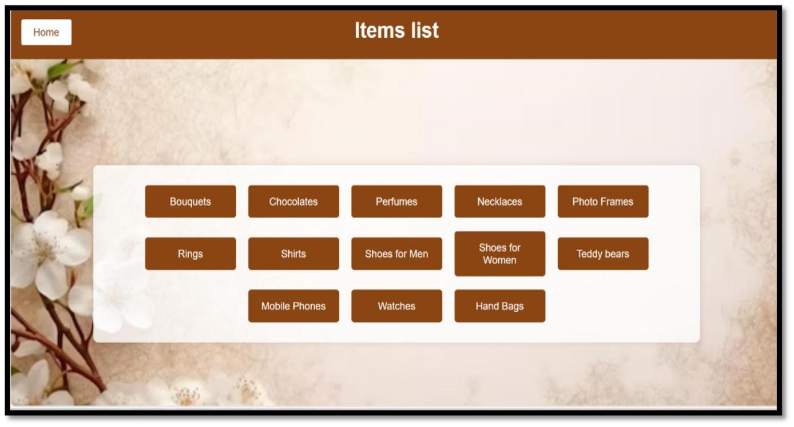

**Bouquets list:**

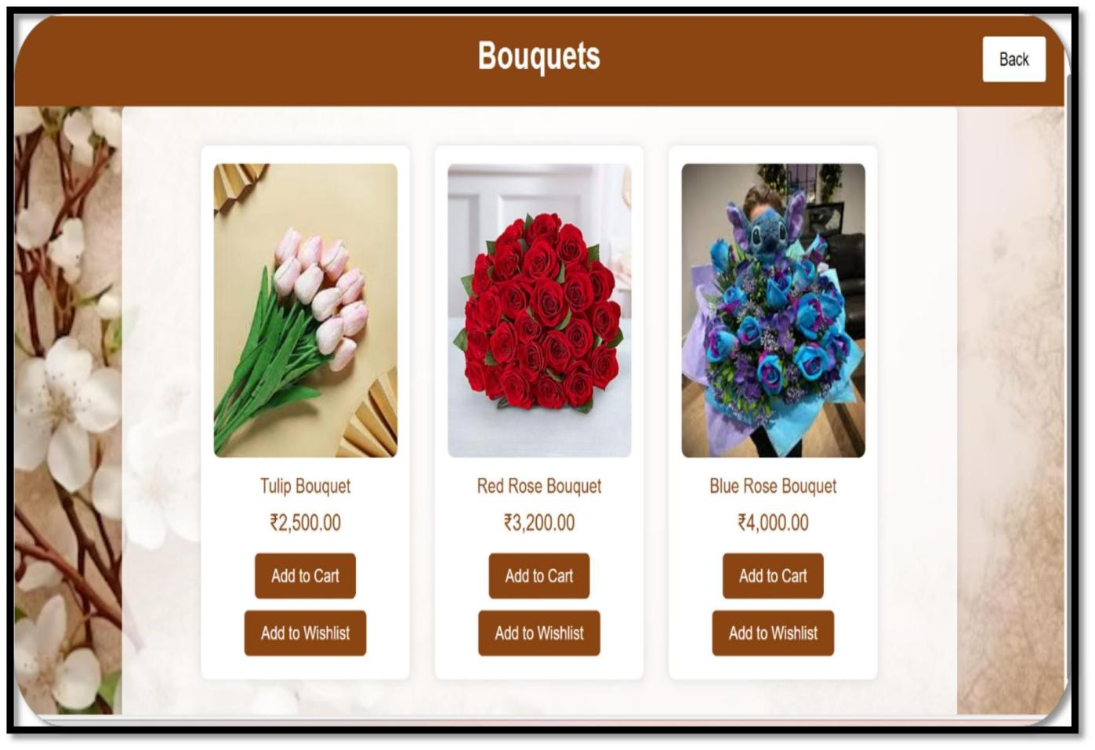

## Chocolates list

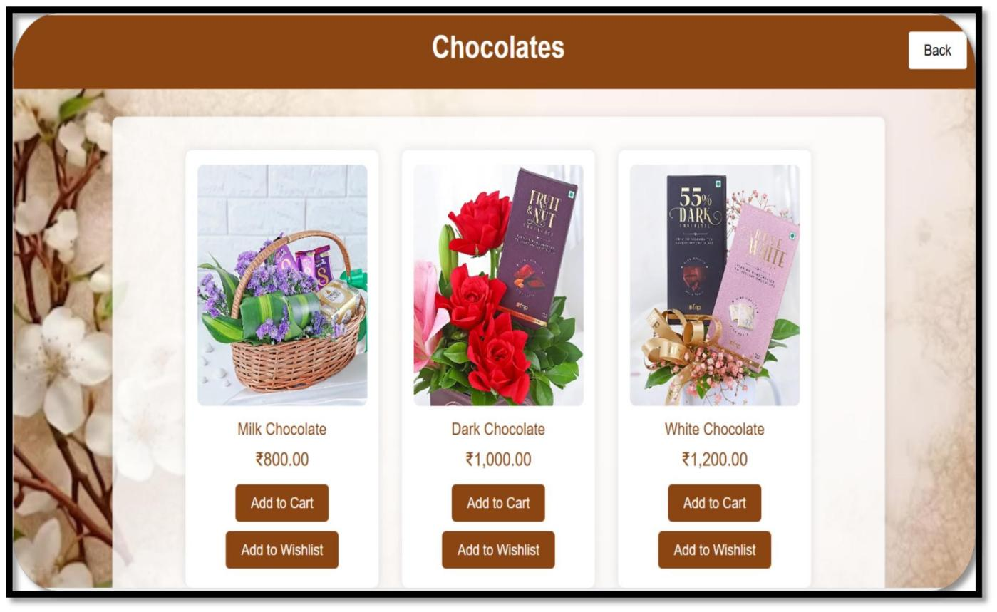

**Perfume List**

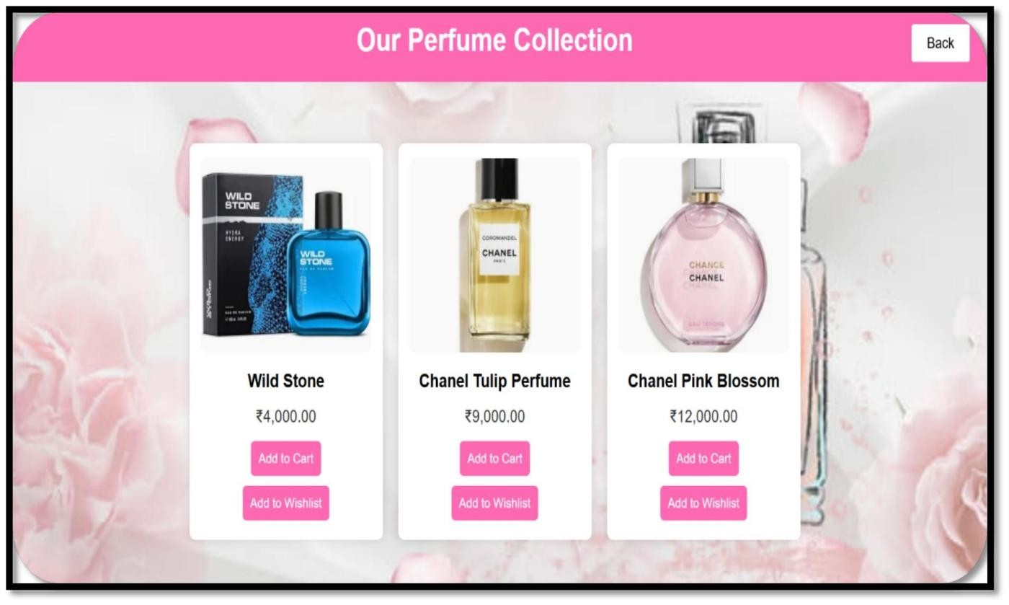

**Teady bear list**

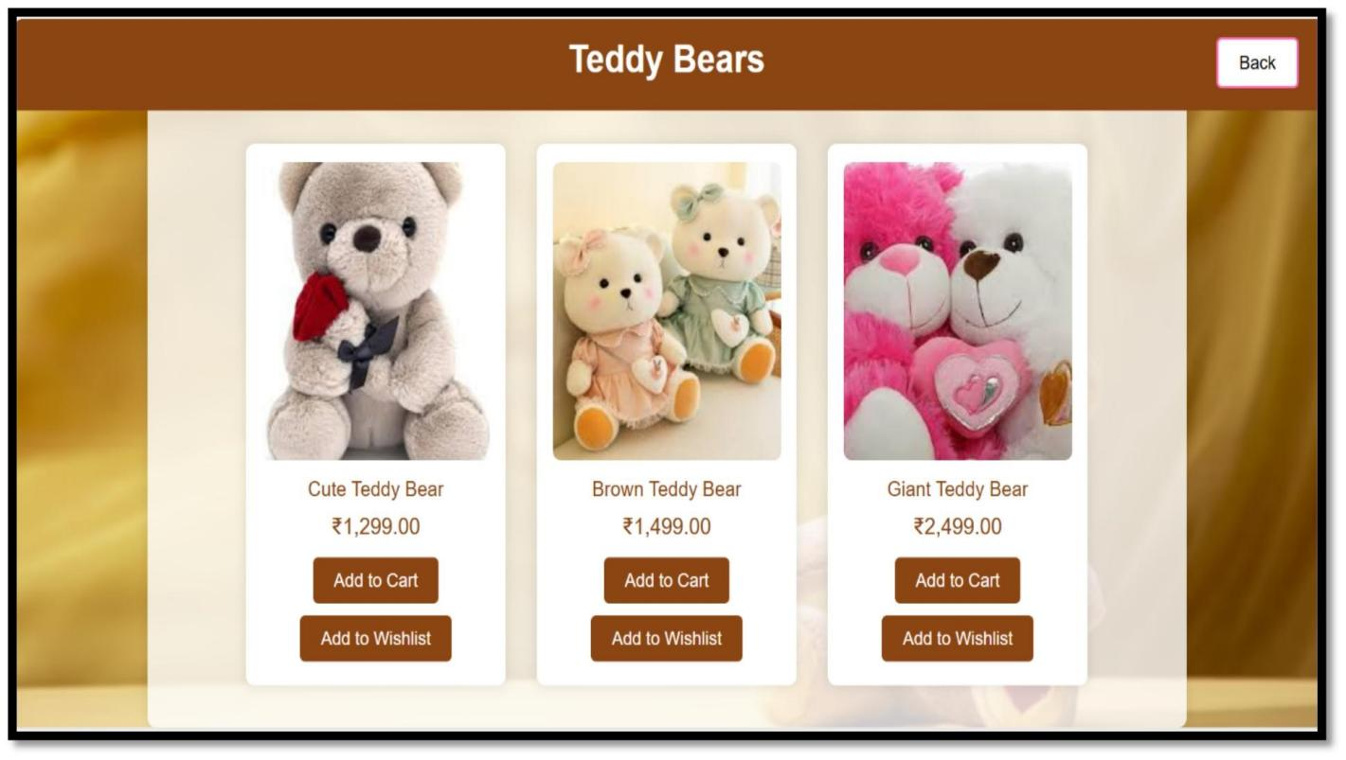

**Ring list**

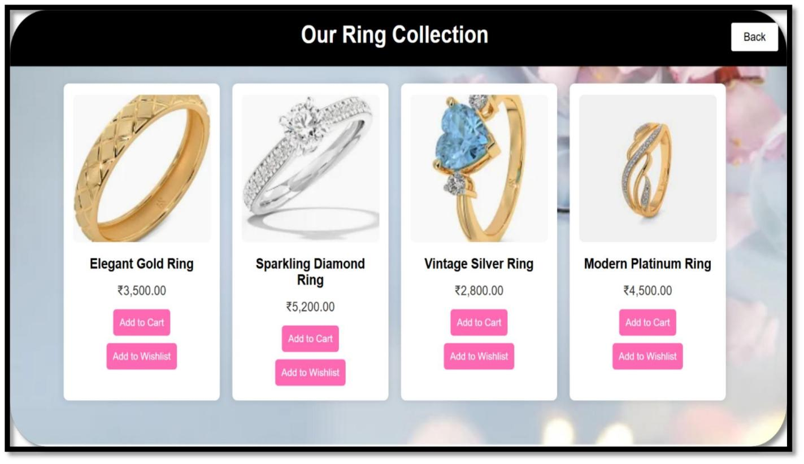

**Cart page**

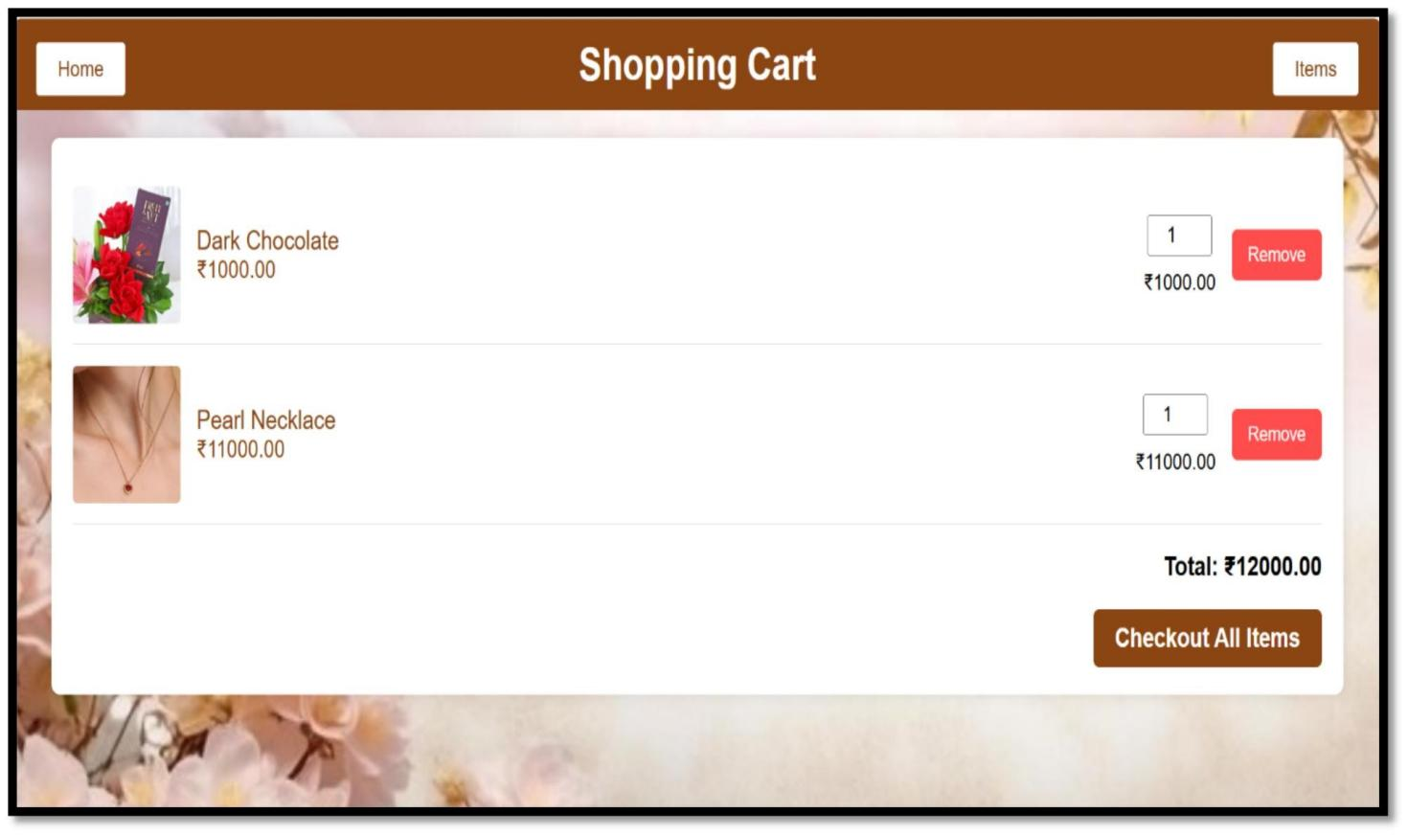

**Wishlist page**

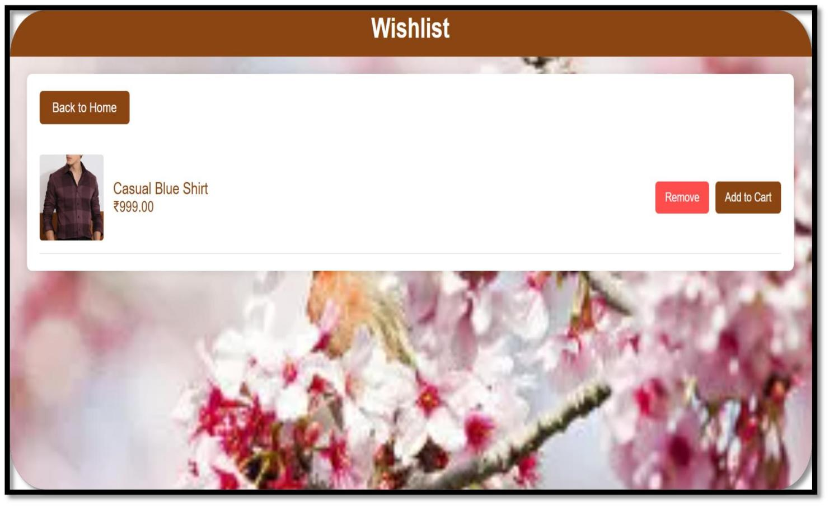

Payment page

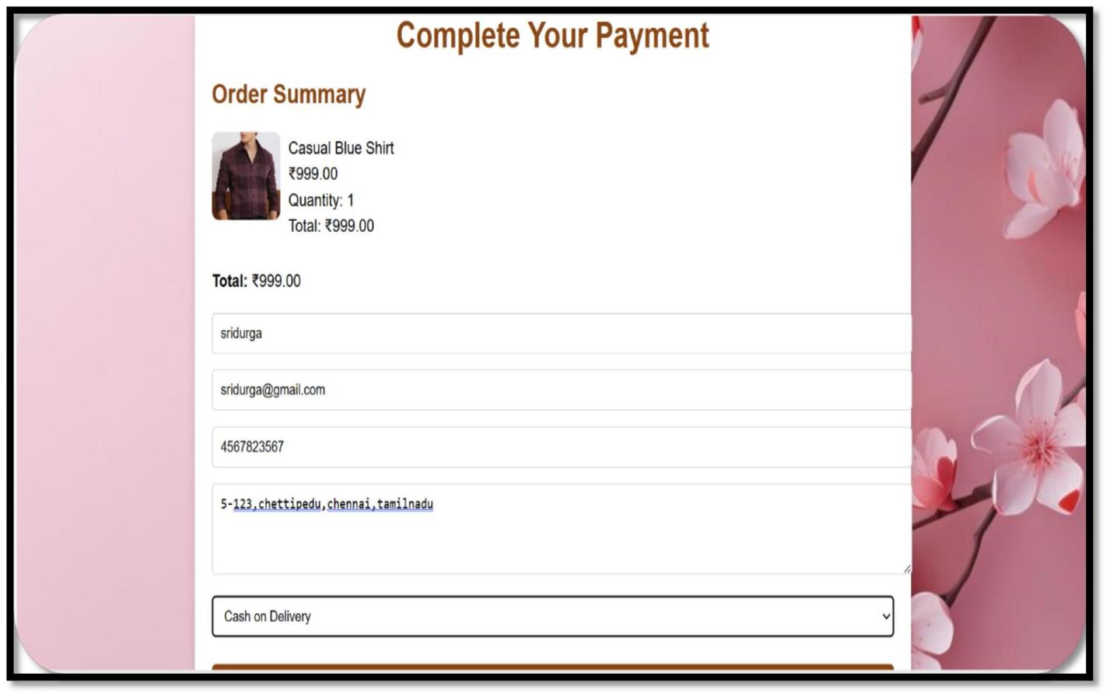

Orders list

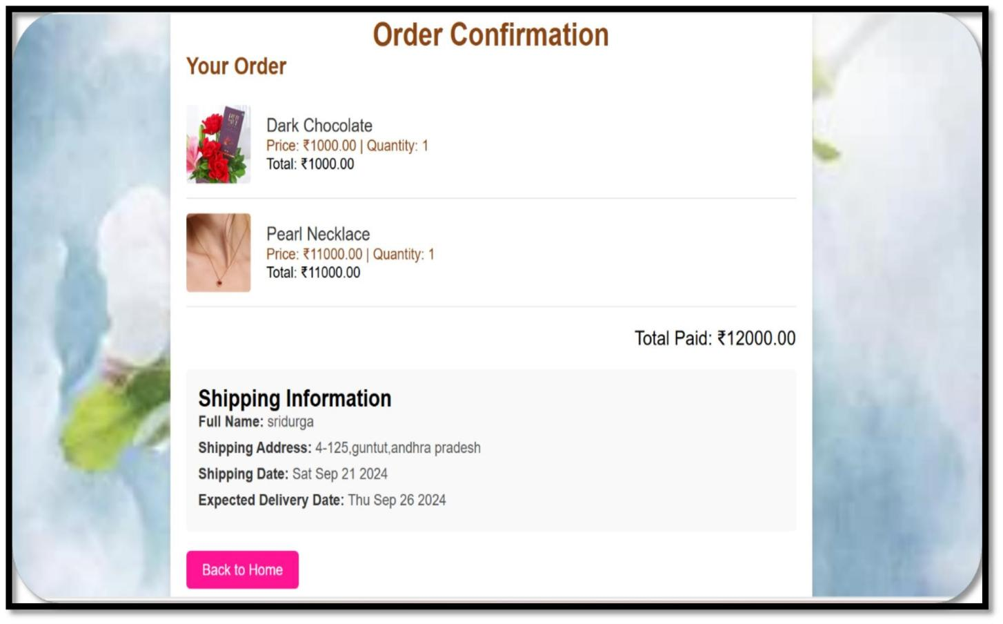

## 9.Conclusion

BlossomGifts is designed to provide a hassle-free and enjoyable experience for customers looking to send flowers and gifts for any occasion. With its wide variety of products, intuitive user interface, and flexible ordering system, the platform caters to the unique preferences of each customer. The real-time tracking feature and secure payment methods ensure a reliable and worry-free shopping process, while special promotions and loyalty discounts reward returning customers. Ultimately, BlossomGifts is committed to making gift-giving a delightful and seamless experience, guaranteeing timely delivery and customer satisfaction every step of the way.

**9.1Future enhancement**

As BlossomGifts continues to evolve, there are several potential future enhancements that can further enrich the user experience and expand the platform's capabilities. One major development could be the integration of artificial intelligence (AI) to provide personalized gift recommendations based on customer preferences, past orders, and trending occasions. By utilizing machine learning, the platform could analyze user behavior and suggest products that best match the recipient's taste and the specific occasion, offering a more tailored shopping experience. Additionally, AI-driven chatbots could assist customers in real-time, answering questions and guiding them through the purchasing process, making the experience even more interactive and seamless.

Another key enhancement could be the introduction of a subscription-based service for recurring gifts and floral deliveries. Customers could subscribe to weekly, monthly, or seasonal plans to have flowers or gifts automatically sent to their loved ones, removing the need for repeat manual orders. This service would cater to those looking to maintain ongoing thoughtful gestures or corporate clients sending regular gifts. Furthermore, BlossomGifts could explore partnerships with eco-friendly brands to offer sustainable packaging and ethically sourced products, appealing to environmentally conscious customers while expanding the platform's appeal to a broader audience.

## 10.References

1. Singh, A. (2021). "Personalization in E-commerce: The Power of Machine Learning and AI." *RetailTech Innovation*. Retrieved from RetailTech Blog
2. John, R. (2022). "Enhancing Customer Support with AI Chatbots." *Digital Customer Service Journal*. Available at AI Trends
3. Peterson, L. (2023). "The Rise of Subscription Services in the E-commerce Landscape." *E-commerce Strategies Weekly*. Retrieved from E-commerce Trends
4. Gopalakrishnan, P. (2022). "How Predictive Analytics are Shaping the Future of Online 1
5. GreenTech Team (2021). "The Future of Eco-Friendly Packaging in E-commerce." *Sustainability Trends Journal*. Available at Sustainability Trends
6. Baker, S. (2020). "AI and E-commerce: How Artificial Intelligence is Transforming Online Retail." *Retail Tech Magazine*. Retrieved from Retail Tech
7. Brown, T. (2021). "How Loyalty Programs Drive Customer Retention in Online Retail." *Customer Engagement Hub*. Available at Customer Engagement
8. Patel, R. (2023). "Leveraging Data Analytics to Predict Consumer Behavior in Ecommerce." *Data Science Applications Journal*. Retrieved from Data Science Apps
9. Green, M. (2022). "Sustainable E-commerce Practices: Reducing Environmental Footprint." *Sustainable Business Review*. Available at Sustainable Business
10. Cooper, J. (2023). "How Real-Time Order Tracking Enhances the Customer Experience." *E-commerce Solutions Blog*. Retrieved from E-commerce Solution